|  |  |
| --- | --- |
| linear IPS | Year 12 Methods  TEST 4 2019  Friday 23 August  TIME: 45 minutes working  One page of notes is allowed.  **Calculator Assumed**  46 Marks 6 Questions |

Name: _______________________________ Teacher: ___________________________

**Note: All part questions worth more than 2 marks require working to obtain full marks.**

**Question 1 (8 marks)**

Consider the function .

1. Sketch the function on the axes below showing all major features. (3 marks)

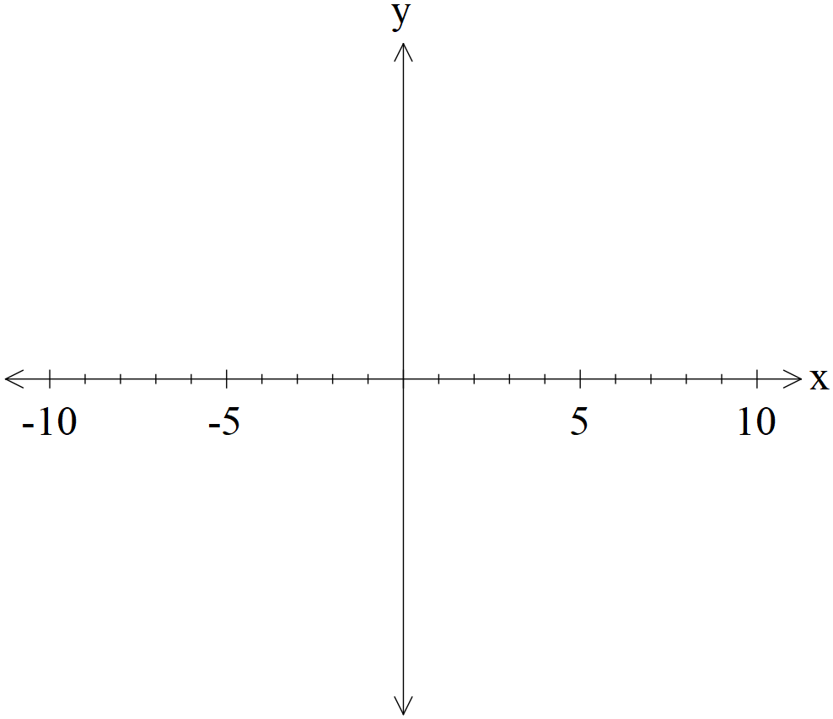

1. Determine the value of ,in terms of , given that . (2 marks)
2. Consider the new function , determine the x coordinate where  on this new function. (Note;  is the same constant as above.) (3 marks)

**Question 2 (15 marks)**

A company makes circuit boards to be used to make computers. The length of the circuit boards is estimated to be Normally distributed with a mean of 35 cm and a standard deviation of 16.7 cm.

A customer will only buy circuit boards that are between 22.5 and 41 cm.

1. Determine the probability that a circuit board will meet the customer’s requirements.

(2 marks)

1. If the company made 20 circuit boards, determine the probability that at least 12 boards would be suitable for the customer. (3 marks)

The government will tax the circuit boards made by the company according to its length. Complete the table below by determining the probabilities to four decimal places..

1. (4 marks)

|  |  |  |  |  |
| --- | --- | --- | --- | --- |
| Length of circuit board |  |  |  |  |
| Tax $ | $5 | $7.50 | $9 | $11.50 |
| Probability |  |  |  |  |

1. Determine the expected tax bill for a circuit board. (2 decimal places) (2 marks)
2. Determine the standard deviation for the tax of a circuit board. (2 decimal places) (2 marks)
3. **Show** one reason why the Normal probability model is not appropriate for the lengths.

(2 marks)

**Question 3 (4 marks)**

The exam data for a cohort of Year 12 Methods students at a school has a mean of 72% and a standard deviation of 22%. The Head of Department needs to scale the results so that the mean is 60% and a standard deviation of 15%. This will be done by multiplying the original scores by a constant  and adding a constant (any order). Determine **two** possible pairs of values of  and the order they should be applied.

**Question 4 (3 marks)**

A pharmaceutical company wishes to gather information on a new form of headache tablets.

Comment on whether there is any bias in the following sampling methods, give reasons.

1. People were surveyed outside a dental clinic. (1 marks)
2. People waiting at a central bus station in the city. (1 marks)
3. People were contacted using random mobile numbers. (1 marks)

**Question 5 (10 marks)**

A probability density function is defined as the following.

 where  is a constant.

Determine the following.

1. the exact value of . (2 marks)
2.  (2 marks)
3. the mean of . (3 marks)
4. the standard deviation of . (3 marks)

**Question 6 (6 marks)**

It is believed that a toy company produces defective toys at a proportion of .

1. A consultant wishes to determine the true proportion  of defective toys within 5% and with a confidence of 90%. Determine how many toys should be taken for sampling.

(3 marks)

1. A year later another sample is taken and a 95% confidence interval for the proportion of defective toys is calculated as . Determine the sample size. (3 marks)